Delmar Pop Warner Sponsorship Levels

Platinum sponsor $1500
- Company Name on Sponsor Banner
- Sponsorship Plaque for Office
- Internet reviews (Google/Facebook)
- Website Link in Delmar Home Page
- Invitation to end of Year Banquet to meet the kids

Gold sponsor $1000
- Sponsorship Plaque for Office
- Internet reviews (Google/Facebook)
- Website Link in Delmar Home Page
- Invitation to end of Year Banquet to meet the kids

Silver sponsor $750
- Sponsorship Plaque for Office
- Internet reviews (Google/Facebook)
- Website Link in Delmar Home Page
- Invitation to end of Year Banquet to meet the kids

Bronze sponsor $500
- Internet reviews (Google/Facebook)
- Website Link in Delmar Home Page
- Invitation to end of Year Banquet to meet the kids

Premier sponsor $250 or less
- Website Link in Delmar Home Page
- Invitation to end of Year Banquet to meet the kids

delmar Pop Warner Contact INfo
President Dorie Simpler 302-236-3589 delmarpopwarner@gmail.com
VP of Football: Frank Roberts 410-422-4231 frankandrear@comcast.net
VP of Cheer: Jennifer Wheatley 443-359-4779 jenniferwheatley25@yahoo.com
Treasurer: Kathy Johnson 443-783-0677 kathyj323@gmail.com

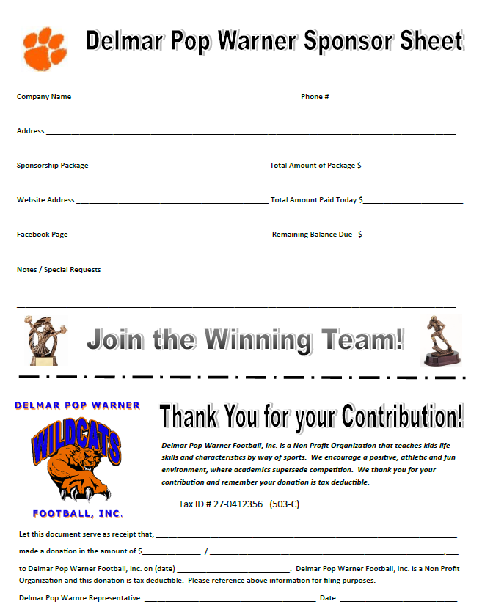

Mail contributions to 34442 Shepherds Hollow Rd. Laurel, De. 19956 Checks should be made out to
Delmar Pop Warner

